**Gibbs’ Reflective Cycle**

1. **Description:**

Firstly, I have received my assignment about writing a research paper proposal. I started with searching for a problem within my knowledge and interests, so I chose sports field and especially soccer. Then it came to my mind the idea of using machine learning and computer vision in soccer to analyze the players’ movements and interactions to provide players’ strengths and weaknesses and give insights for coaches. Moreover, predicting the future performance of players during matches and predicting the probability of injuries and taking penalty cards. All of these help the coaches to make more informed decisions and improve team performance. After dedicated work, I have managed to do my research well in time.

1. **Feelings:**

Throughout the experience, I felt excited and enthusiastic as I went through the research proposal process. There was also a sense of uncertainty and hesitation, especially while choosing the topic and writing the study proposal. However, as I advanced and improved my idea further, emotions of confidence and commitment grew, pushing me to investigate the possibility of using machine learning and computer vision in soccer analysis. As I progressed through the assignment's steps, I experienced a range of emotions, from curiosity to excitement.

1. **Evaluation:**

The research proposal requires a lot of time and work to put together. While my concentration on utilizing machine learning and computer vision in soccer analysis, it was exciting but challenging because there were few current papers or data on this topic. To discover appropriate information, I went through a variety of resources, including Google Scholar. Despite the difficulties, the exploration of new concepts in sports research was thrilling and exciting. Overall, it was an educational experience that needed patience and determination.

1. **Analysis:**

Based on the research proposal process, multiple factors had a crucial role in its success. Consistently allocating time to the project, with specified weekly assignments, allowed for consistent development and timely completion. Despite the difficulties in contacting coaches for interviews, the efforts of peers and mentors were critical in creating connections and offering access to essential coaches. Having an instructor who gave advice and monitoring was really helpful in navigating the difficulties of the research journey.

1. **Conclusion:**

Reflecting on the research process, I have identified a few areas for improvement in future projects. Primarily, I aim to conduct more interviews and broaden my network of contacts within the coaching community, which will include individuals from all kinds of backgrounds and perspectives. This will improve the qualitative data collected and offer a more complete understanding of the research problem. Furthermore, I intend to improve the thematic analysis by including additional questions and themes to deepen the analysis and capture hidden results. In addition, to supplement the qualitative approach, I hope to collect a dataset to run smaller-scale simulations or simpler version of the study objective and build a model, allowing for methodology validation and refining.

1. 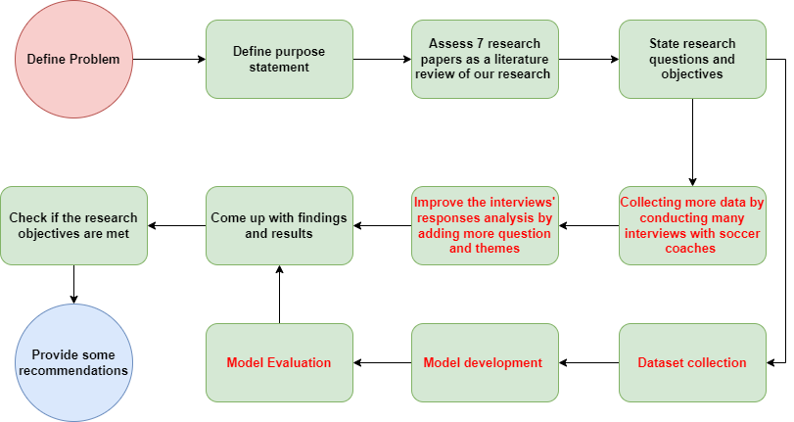**Action Plan:**

My action plan consists of dual actions: firstly, I would increase the interviewed soccer coaches and broaden the segment to include coaches from different backgrounds and perspectives. Also, I would increase the interview questions in order to gather more valuable information from the coaches and come up with more themes to be discussed and extracted from their interviews. Moreover, I would gather soccer data in order to build a CV & ML model that analyzes this data and predict depending on it the future performance, including the predicting the likelihood of player receiving an injury or penalty cards. After developing the model, I would evaluate the accuracy and efficiency of the model by testing it on unseen testing data. After all of that, I would come up with new findings and results and continue the same steps.